**CSE 379 Project - Progress Report 2**

Matt Raporte and Greg Potter

This week was primarily finalizing exactly what our plan would be. We met with Professor Huang to figure out what aspects of the project we would focus on. Below is the proposed Gantt chart which was presented on Thursday:

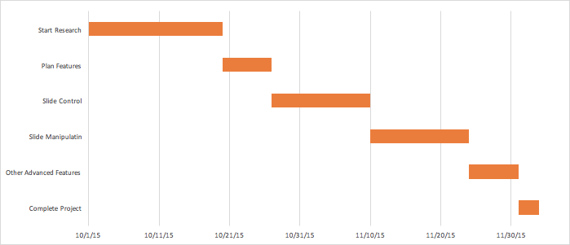

We are currently on track in the “Start Research” phase. We got the SDKs installed for LeapMotion and started looking into what the raw data looks like. We haven’t written any actual code but looked at many samples and we should be able to start customizing the actual gestures this week. In terms of the Microsoft APIs, there seem to be pretty straightforward API commands to control the slides (and other functionality). We got some basic code working which just advances the slide. We’ll need to start talking about how to integrate the two pieces soon. We made sure that our project was going to be advanced enough that it wouldn’t just be a couple lines of code and based on our initial look, we are in a good position.